Design Documentation

**Faculty Research**

**Database**

ISTE 330.01

Team 14

Name Email

Dominico Tran dxt4298@g.rit.edu

Ellie Parobek arp6333@g.rit.edu

Kevin Lozano kxl3544@g.rit.edu

Rachael Simmonds rms1252@g.rit.edu

Vignesh Kumar vk4534@g.rit.edu

**ER Diagram:**

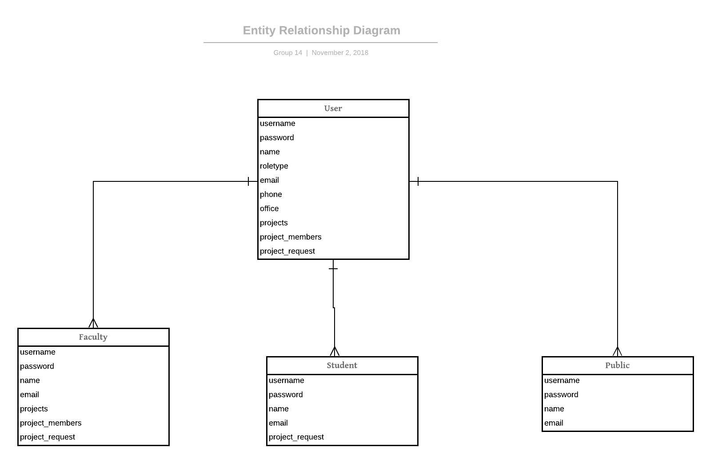

**ER Diagram explained:**

The database comprises of 4 tables user, faculty, student and public. The user table will hold all the credentials for students,public and faculty. The user table acts as a supertype and the rest are subtypes.

**UML Diagram:**

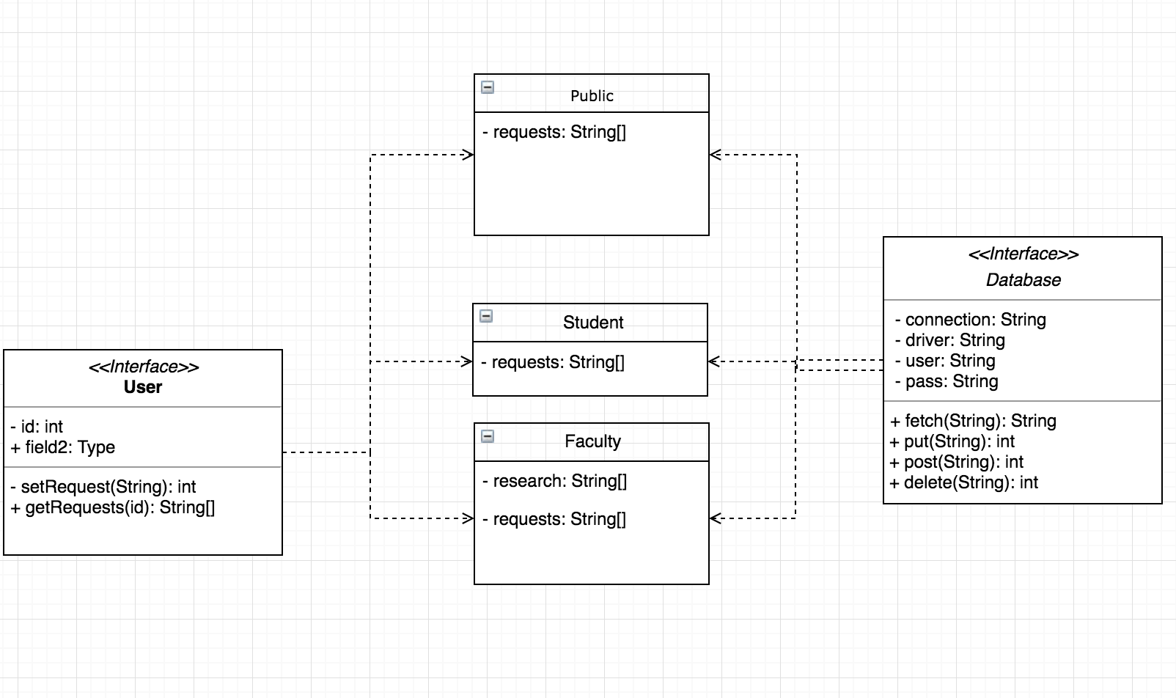

**UML Diagram explained:**

The User interface contains similar functionality between all child classes: Public, Student, and Faculty which also inherit from the Database Interface which contains all DB related functions such as fetch, put, post, and delete. Any unique functionality will be included in Public, Student, or Faculty respectively.

**Choice of Languages:**

* PHP
* HTML
* CSS
* JS
* MySQL

**How the info will be passed between layers:**

Information will be gathered in the Database Interface, and then formatted in the child classes for their specific use cases before being passed to the Application Layer (front-end). Our back-end language of choice is PHP, with HTML, CSS, and JS on the front-end so passing data from back-end to front-end should be seamless.

**Sketch of User Interfaces:**

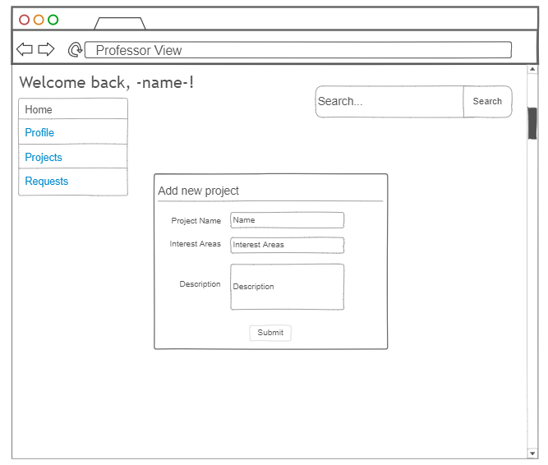

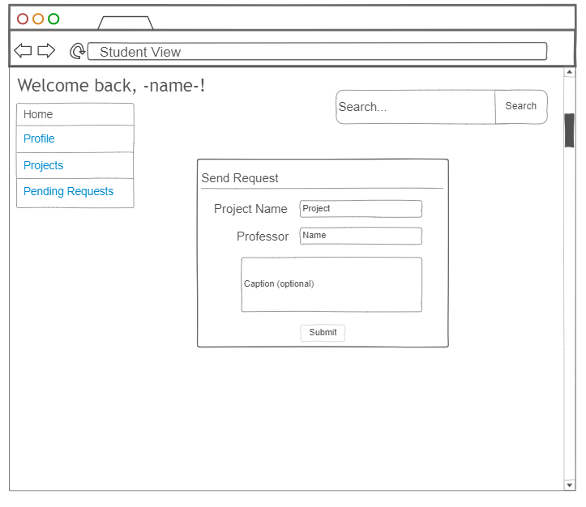

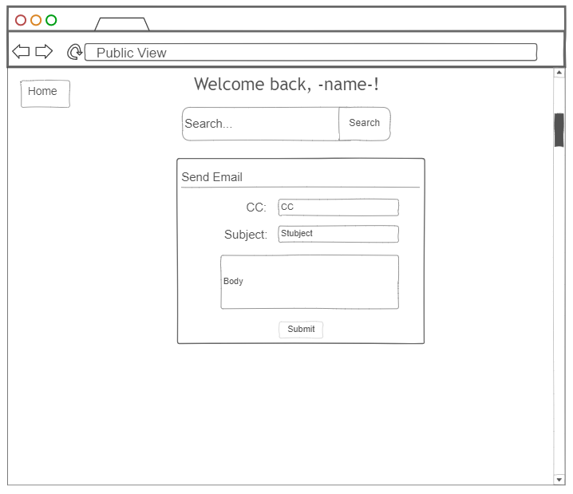

**Key Functionality:**

Professors: The professors functionality would allow them to create and search any project that has been uploaded. As well as approve or deny any student that sends a request ticket to work with them on a project.

Student: Students may send a request form for the professors to work on a project as well as search for project(s) that they are interested in.

Public: May only search for projects.

**Areas of Concern:**

We are mostly concerned about the back end programming language we will be using. Whether or not it is Java or PHP. We want to choose the most compatible language with HTML and CSS.